#### ****TUTORIAL :- 3 [Week -3 ]****

### ****Step 1: Identify Inputs and Outputs****

**Inputs:**

| **Input** | **Description** |
| --- | --- |
| DRIV | Driver present (1 = yes, 0 = no) |
| PASS | Passenger present (1 = yes, 0 = no) |
| IGN | Ignition on (1 = yes, 0 = no) |
| BELT_D̅ | Driver seatbelt unfastened (active LOW, 0 = fastened, 1 = unfastened) |
| BELT_P̅ | Passenger seatbelt unfastened (active LOW, 0 = fastened, 1 = unfastened) |

**Output:**

| **Output** | **Description** |
| --- | --- |
| ALARM | Alarm signal (0 = off, 1 = on) **or as described, alarm active LOW (0 = active)** |

Since the alarm is **active LOW**, we’ll assume:

ALARM = 0 → Alarm is ON

ALARM = 1 → Alarm is OFF

### ****Step 2: Express conditions for each seat****

**Driver triggers alarm if:**

DRIV = 1 \quad \text{AND} \quad BELT_D̅ = 1

**Passenger triggers alarm if:**

PASS = 1 \quad \text{AND} \quad BELT_P̅ = 1

**Either seat triggers alarm (OR condition):**

(DRIV \cdot BELT_D̅) + (PASS \cdot BELT_P̅)

**Combine with ignition (AND condition):**

IGN \cdot [(DRIV \cdot BELT_D̅) + (PASS \cdot BELT_P̅)]

### ****Step 3: List All Input Combinations****

We have **5 inputs**: DRIV, PASS, IGN, BELT_D̅, BELT_P̅  
So there are 25=322^5 = 32 combinations.

| **DRIV** | **PASS** | **IGN** | **BELT_D̅** | **BELT_P̅** | **ALARM (active LOW)** |
| --- | --- | --- | --- | --- | --- |
| 0 | 0 | 0 | 0 | 0 | 1 (OFF) |
| 0 | 0 | 0 | 0 | 1 | 1 (OFF) |
| 0 | 0 | 0 | 1 | 0 | 1 (OFF) |
| 0 | 0 | 0 | 1 | 1 | 1 (OFF) |
| 0 | 0 | 1 | 0 | 0 | 1 (OFF) |
| 0 | 0 | 1 | 0 | 1 | 1 (OFF) |
| 0 | 0 | 1 | 1 | 0 | 1 (OFF) |
| 0 | 0 | 1 | 1 | 1 | 1 (OFF) |
| 0 | 1 | 1 | 0 | 1 | 0 (ON) |
| 1 | 0 | 1 | 1 | 0 | 0 (ON) |
| 1 | 1 | 1 | 1 | 1 | 0 (ON) |

**Step :4 Flowchart :**

**Legend (used in the chart):**

IGN = 1 → ignition ON

BELT_D̅ = 0 or BELT_P̅ = 0 → belt is **unfastened** (active-LOW)

ALARM = LOW → alarm **ON** (active-LOW)

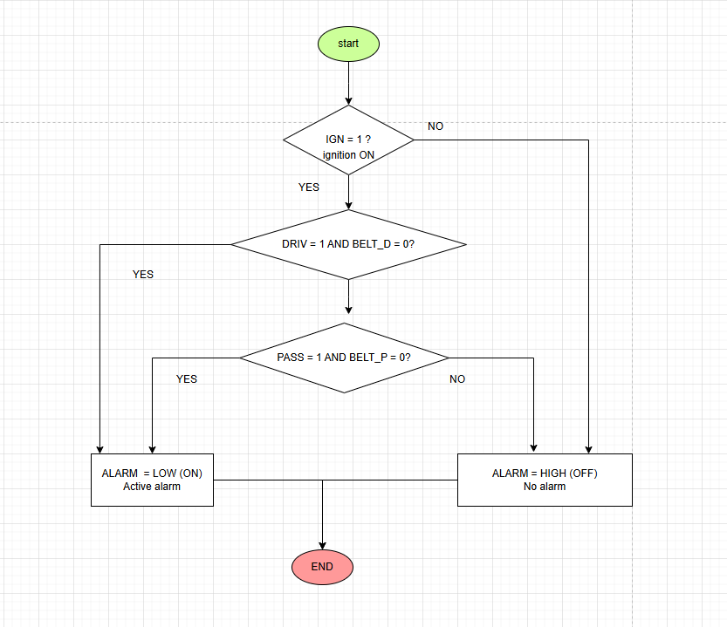

### Step 5 : ****Pseudocode Version****

START

IF IGN = 0 THEN

ALARM = 1 // Alarm OFF

ELSE

IF (DRIV = 1 AND BELT_D̅ = 1) OR (PASS = 1 AND BELT_P̅ = 1) THEN

ALARM = 0 // Alarm ON

ELSE

ALARM = 1 // Alarm OFF

ENDIF

ENDIF

END

**Logic chart**

